 

Qatar University

Operating System CMPS 405

PROJECT #1

Eng. Ahmed Hussain

Amira Abdalla 201802220

Nirvana Aladal 201802829

Maryam AlHumaidi 201701341

**Tasks Distribution**

|  |  |
| --- | --- |
| Nirvana Aladal | Completed 1.1 first shell script + 2.3 sixth shell script + word document |
| Maryam AlHumaidi | Completed 1.2 second shell script + 2.1 forth shell script |
| Amira Abdalla | Completed 1.3 third shell script + 2.2 fifth shell script and part 2 C programming |

Table of Contents

First Shell Script (Running.sh) 3

#first subroutine 3

#Second subroutine 5

Output 6

sub1 6

sub2 7

Second Shell Script (Performance.sh) 8

#subroutine no. 1 8

#subroutine no. 2 9

#subroutine no. 3 9

Output 11

Disk_Usage.txt 15

Cpu_info.txt 17

Message_Count.txt 17

HDMessages_Log.txt 18

Third Shell Script (FileSystem.sh) 20

#sub1 20

#sub2 20

#sub3 21

Output 21

HOLDFile.txt 22

OUTFILE.txt 22

Fourth Shell Script (ControlTraffic.sh) 23

Subroutine_1() { 23

Subroutine_2(){ 23

output 24

Fifth Shell Script (Connectivity.sh) 25

#subroutine 25

output 26

Sixth Shell Script (Trap.sh) 27

#subroutine 27

output 27

Part 2 – C programming 28

Fibonnaccinumber.c 28

Makefile 29

output 29

# First Shell Script (Running.sh)

#!/bin/bash

## #first subroutine

function firstsub(){

#Takes from the user the username

echo "Enter user name:"

read username

#display a welcome username

echo "Welcome $username"

echo "******************************************************"

#Message

echo -e "$username is currently logged in the linux system\n"

#echo -e to use escaped characters

Day=$(date +%a) #creating variable Day that shows the weekday name

day=$(date +%d) #creating variable day that shows the day of month

mon=$(date +%b) #creating variable mon that shows the abbreviated month name

year=$(date +%Y) #creating variable year that shows the year

time=$(date +%X) #creating variable time that shows the time representation

zone=$(date +%Z) #creating variable zone that shows the time zone

boottime=$(who -b) #creating variable holds time of last system boot

idletime=$(who -u) #creating variable idletime holds idle time

size=$(du -sk $HOME) #creating variable size that estimates file space storage

#Display Current day in a calendar format

echo "The current month calendar "

cal

#Display the current time using variable reference

echo -e "The time on the linux system is $Day $day $mon $year $time $zone \n "

#Display System boot time and idle time using variable reference

echo -e "$boottime and system idle time $idletime \n"

#Working path and Shell type

echo "The current working path is $(pwd)"

echo "The current working shell is $SHELL"

#the directory size in KB in your Home

echo "My home directory is $HOME with the directory size in my home = $size KB "

#Message briefly describing the requited tasks

echo "The purpose of the script: "

echo "The required tasks are given in order to log and track the activity of the users by displaying and saving their information such as date, time, boot time, idle time, working path, shell type, home directory and its size. "

echo "******************************************************"

echo -e "Waiting for results...\n"

}

## #Second subroutine

function secondsub(){

#runs indefinitely

while true

do

#checking constantly to avoid intruptions

trap ./Trap.sh SIGTERM

trap ./Trap.sh SIGINT

#Get current system time

currenttime=$(date +%H:%M)

#checking if time is equal to 11:59

if [[ "$currenttime" == "11:59" ]]; then

#Sets off the first two scripts

./ControlTraffic.sh

./Connectivity.sh

#Waiting for 10 minutes for call the other two scripts

sleep 10s

#run remaining scripts

./FileSystem.sh

./Performance.sh

fi

done

#end of loop

}

#call the first soubroutine

firstsub

#call the second soubroutine

secondsub

## Output

### sub1

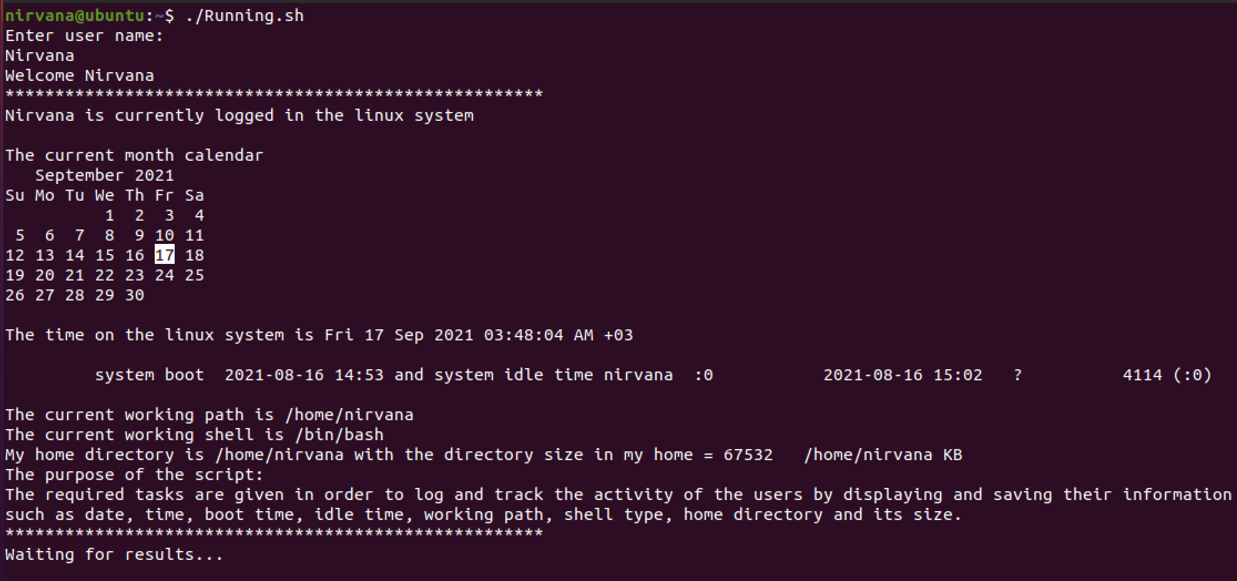

sub2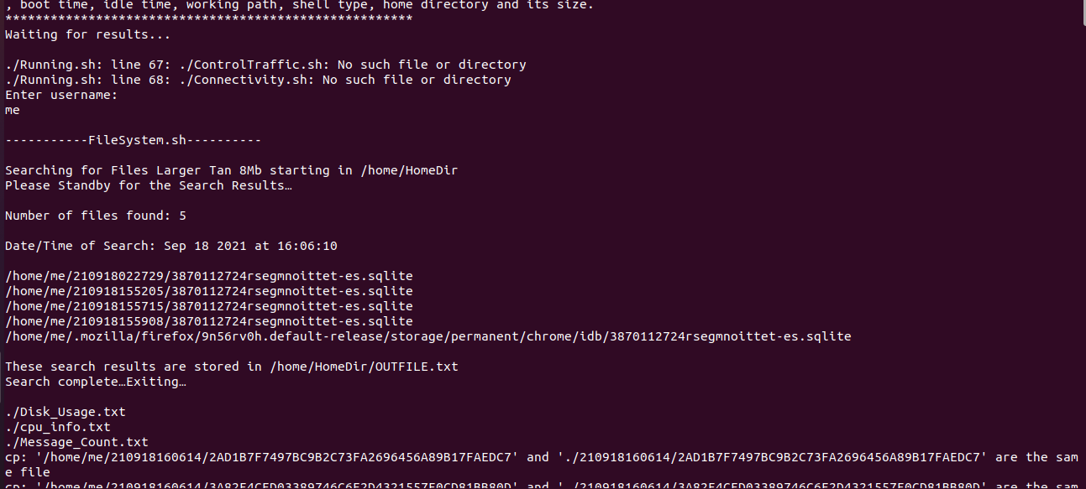

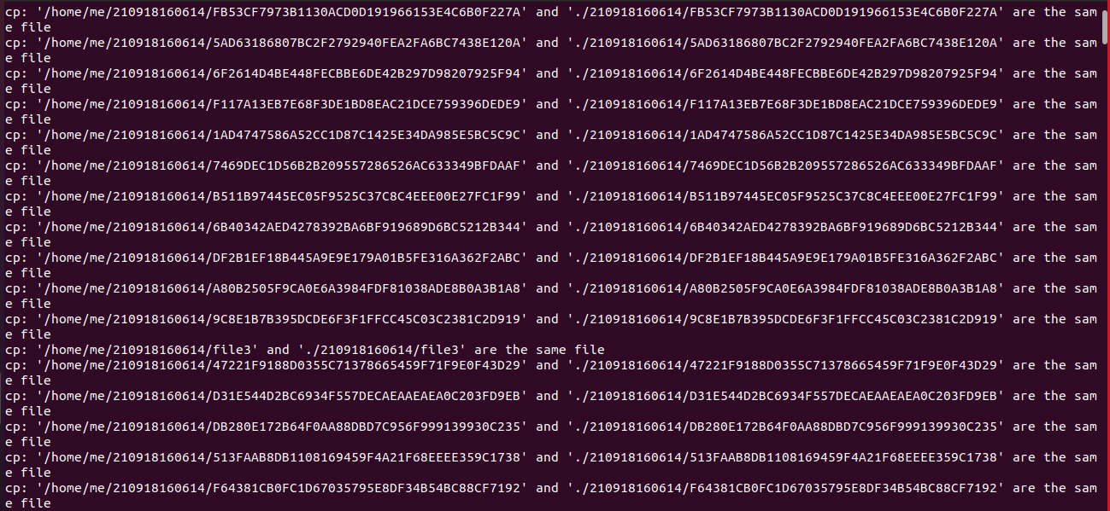

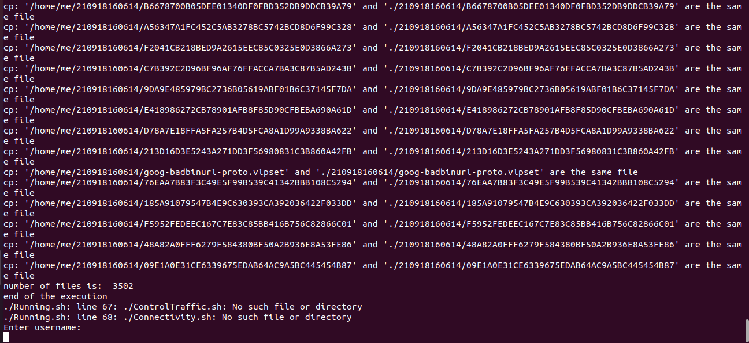

*Loop runs infinitely

*ControlTraffic.sh and Connectivity.sh will run after the completion of phase 2

* FileSystem.sh and Performance.sh run after 10s

# Second Shell Script (Performance.sh)

## #subroutine no. 1

**subroutine1(){**

**#The below command redirects the output for used disk space and write the details of used hdd in reserve order to a file named Disk_Usage.txt**

**du $HOME -hs > Disk_Usage.txt**

**du $HOME | sort -n -r >> Disk_Usage.txt**

**#Getting the kernel buffer output realted to memory and redirecting it to memo-HDMessages_Log.txt**

**dmesg | grep -i memory > memo-HDMessages_Log.txt**

**#Getting the kernel buffer output realted to hard disk and appending it to memo-HDMessages_Log.txt**

**dmesg | grep -i sd >> memo-HDMessages_Log.txt**

**#Collecting CPU information and redirecting it to cpu_info.txt**

**lscpu > cpu_info.txt**

**#count words in kernel output file only related to memory and hard disk and writing it to Message_Count.txt**

**echo "Word count is: $(wc -w memo-HDMessages_Log.txt) " > Message_Count.txt**

**# Generating compressed tar for files "Disk_Usage.txt", "cpu_info.txt" and "Message_Count.txt" named per current date**

**tar -czvf Phase1.tar.gz ./Disk_Usage.txt ./cpu_info.txt ./Message_Count.txt # c creates new archive**

**file=Phase1.tar.gz**

**#copying compressed tar to a new folder named current date and time**

**currdate=$(date +"%H%M%S")**

**mkdir -p "$currdate" && cp "$file" "$currdate"**

**}**

**#Getting day and time for naming the directory**

**currday=$(date +"%y%m%d%H%M%S")**

## #subroutine no. 2

**subroutine2(){**

**#Making directory, finding and copying files from home with read and write permission for owner, copying them to new directory and changing permission to read only for owner**

**mkdir -p "$currday" && find $HOME -type f -perm -u+rw -exec cp "{}" "./$currday" \; && find "./$currday" -type f -exec chmod u=r "{}" \; # "find -perm mode" is the basic command for finding files based on permissions.**

**}**

## #subroutine no. 3

**subroutine3(){**

**#Counting files we copied from home having read permission only for the owner**

**numFiles=$(ls "./$currday" | wc -l)**

**#Displaying the count of files and end of execution**

**echo "number of files is: " $numFiles**

**echo "end of the execution"**

**}**

**#running subroutines**

**subroutine1**

**subroutine2**

**subroutine3**

## Output

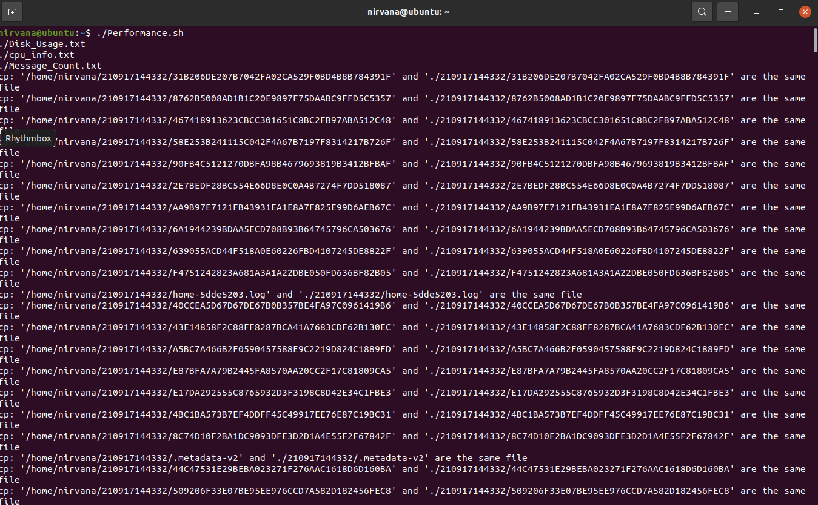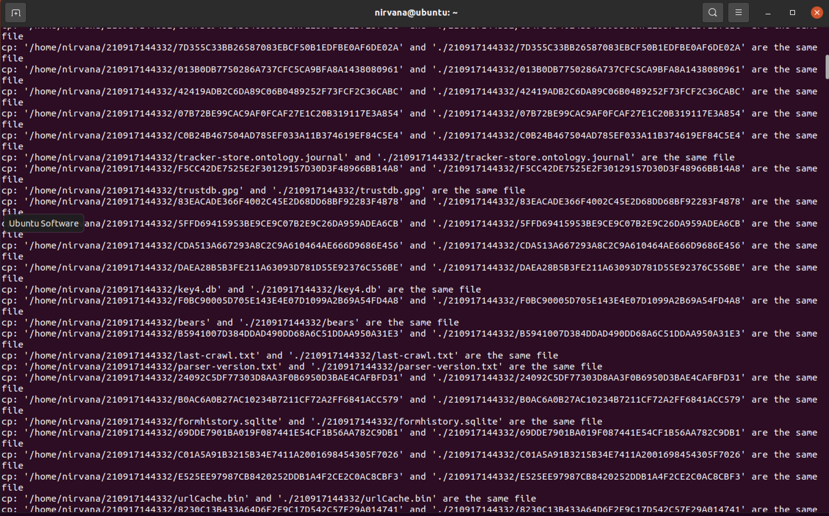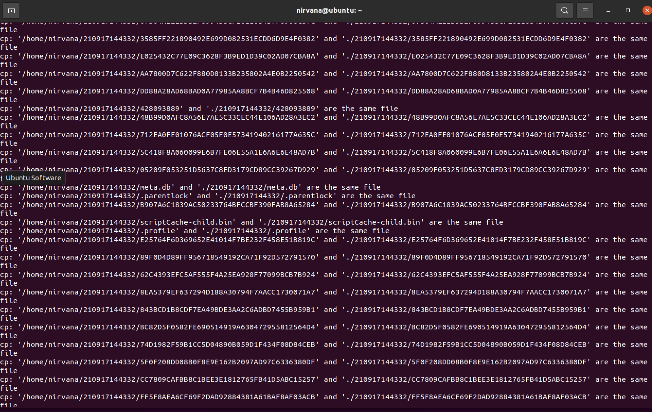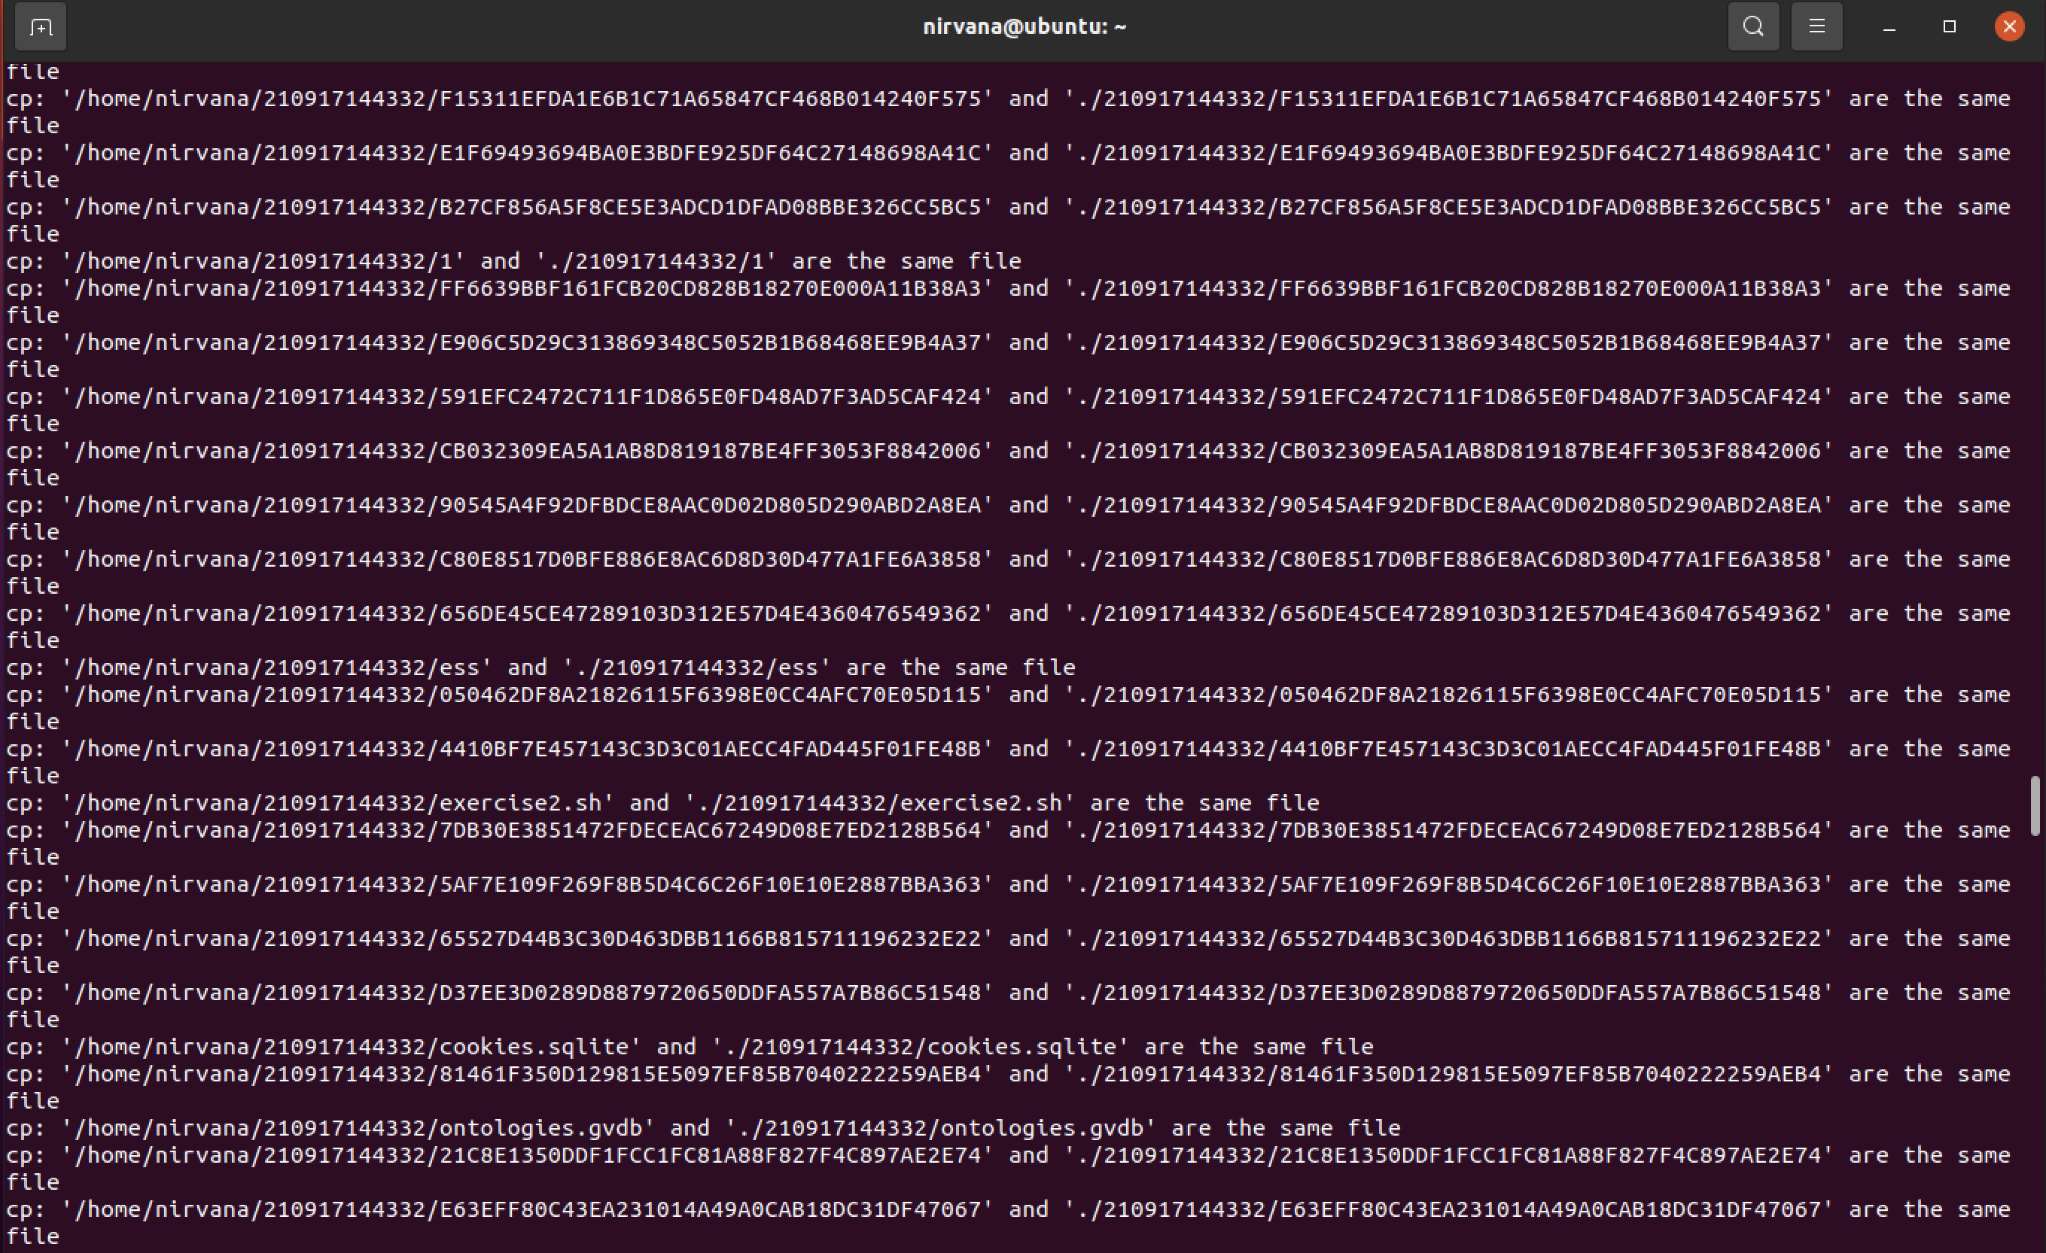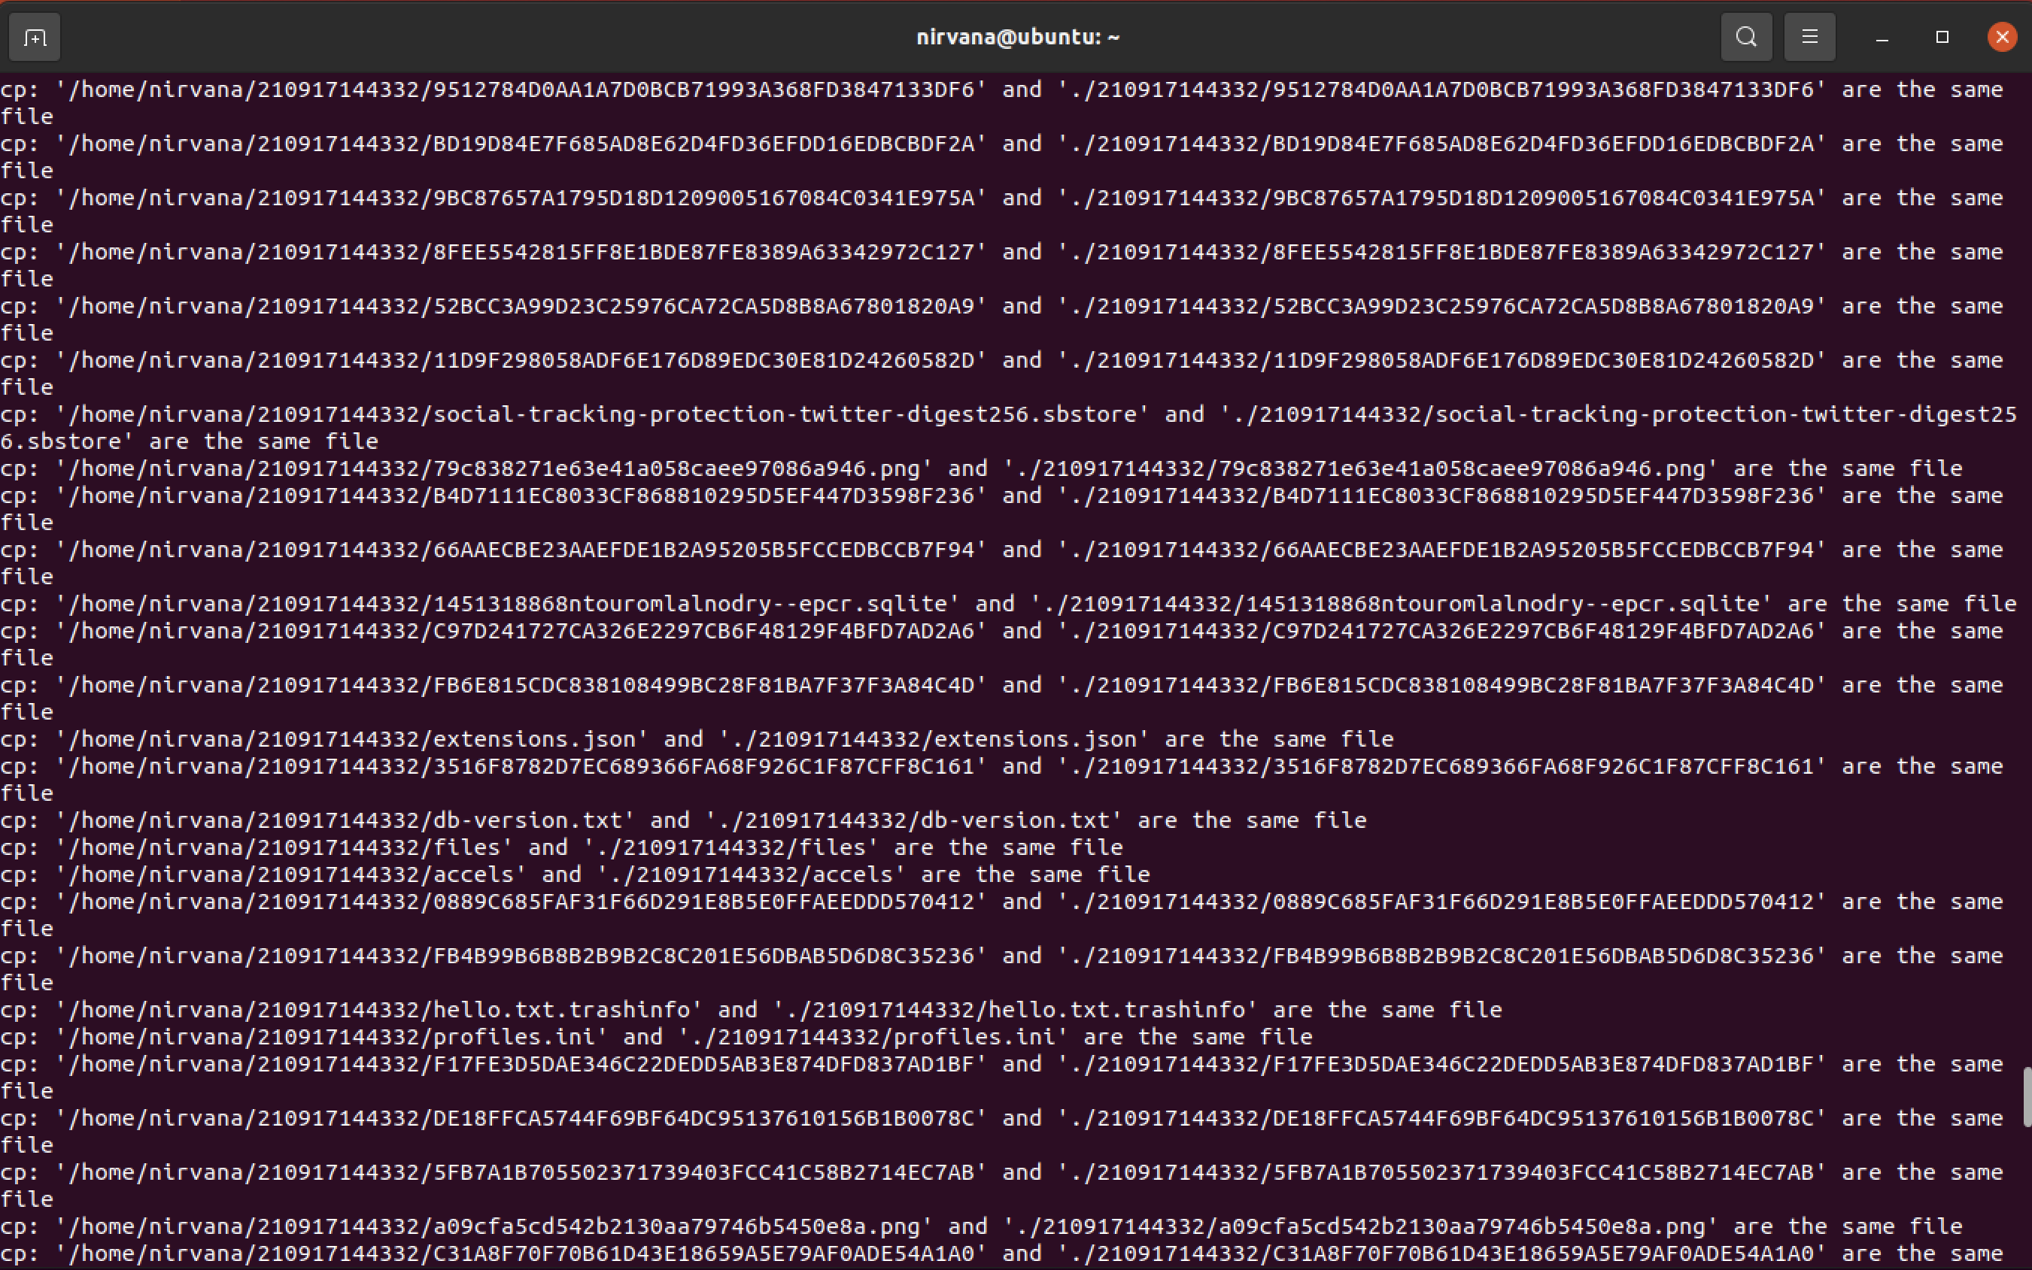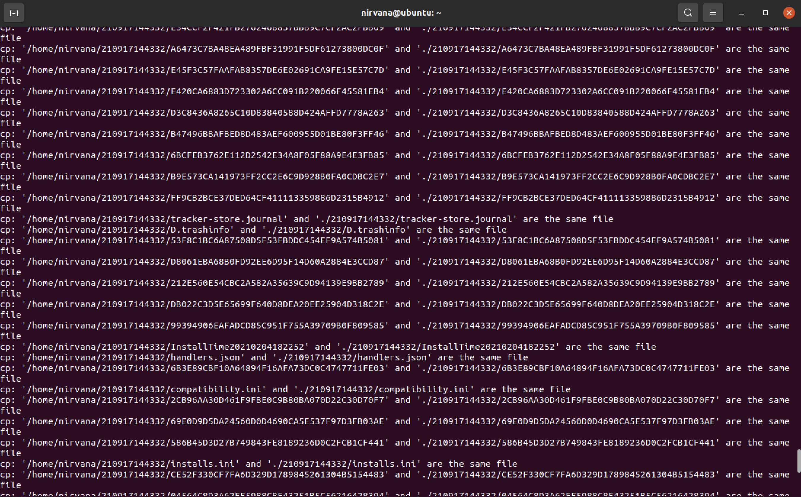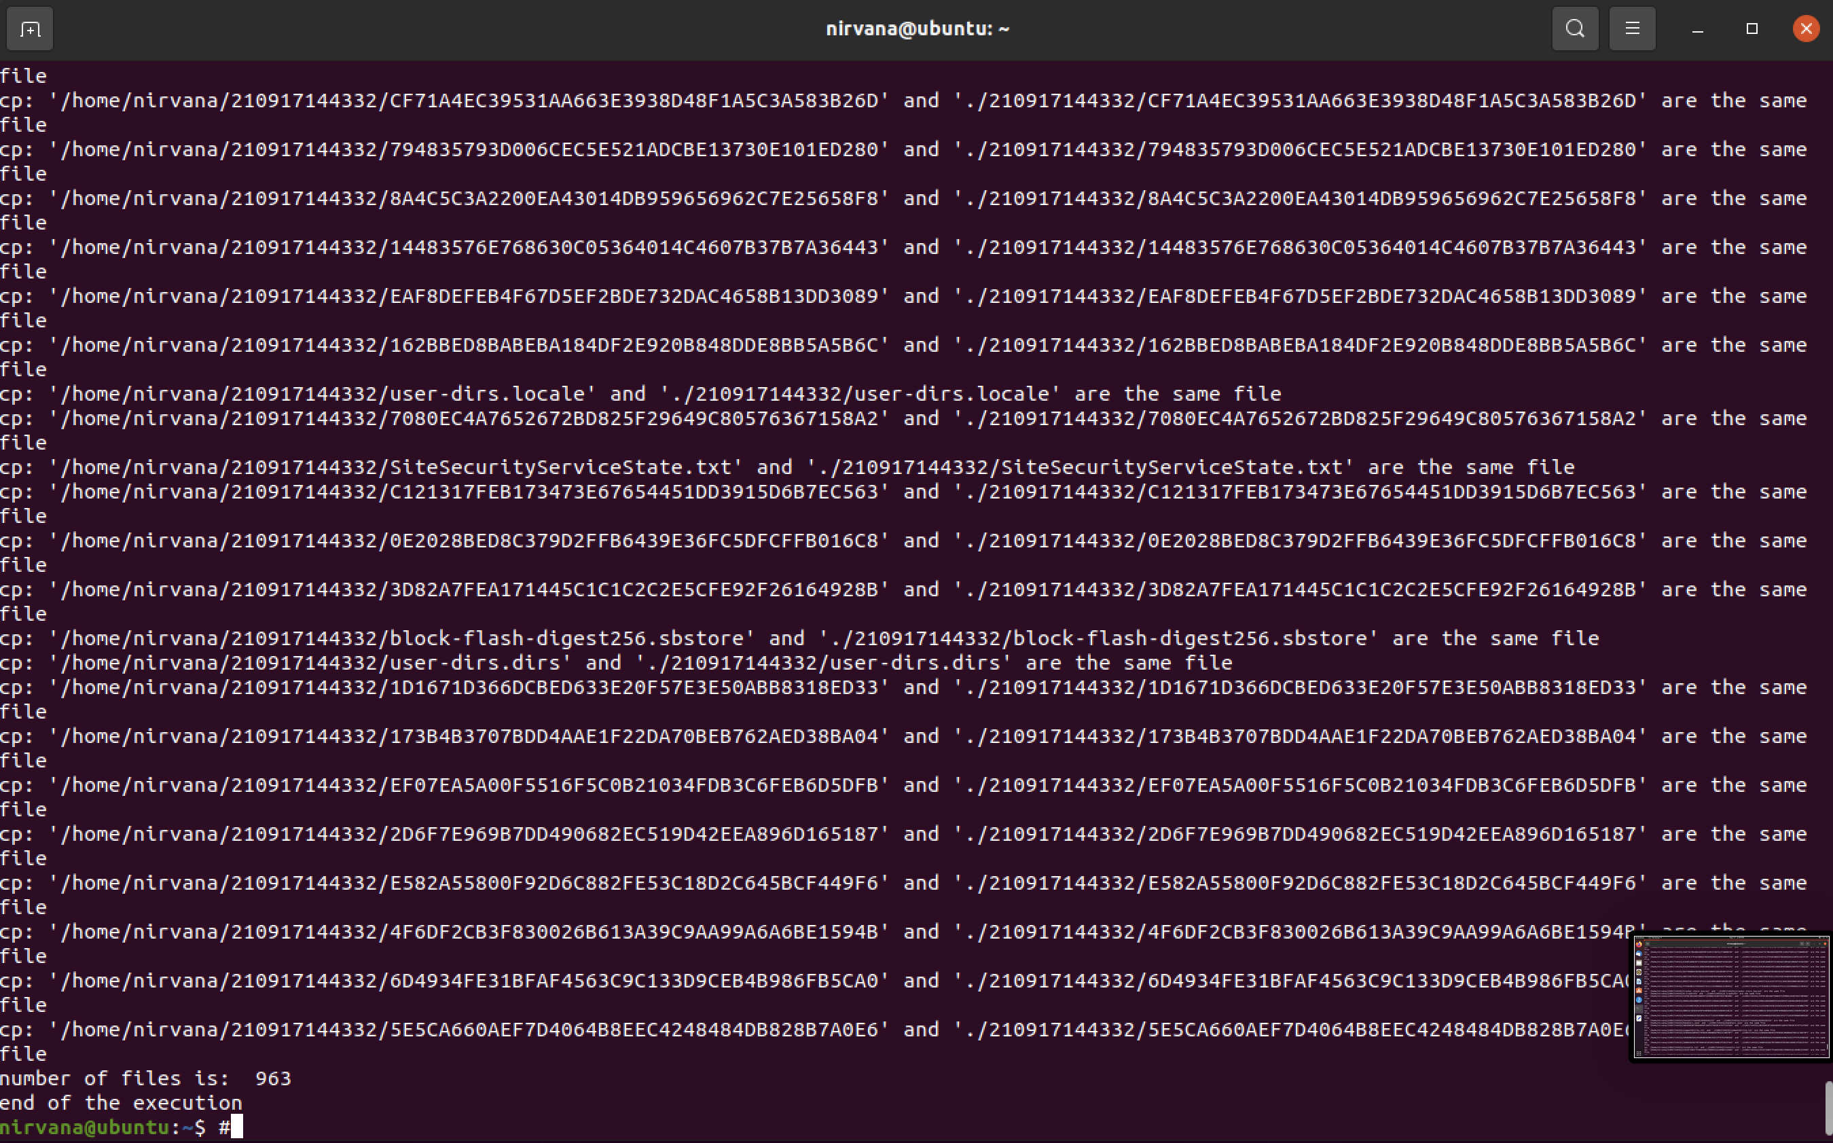

### Disk_Usage.txt

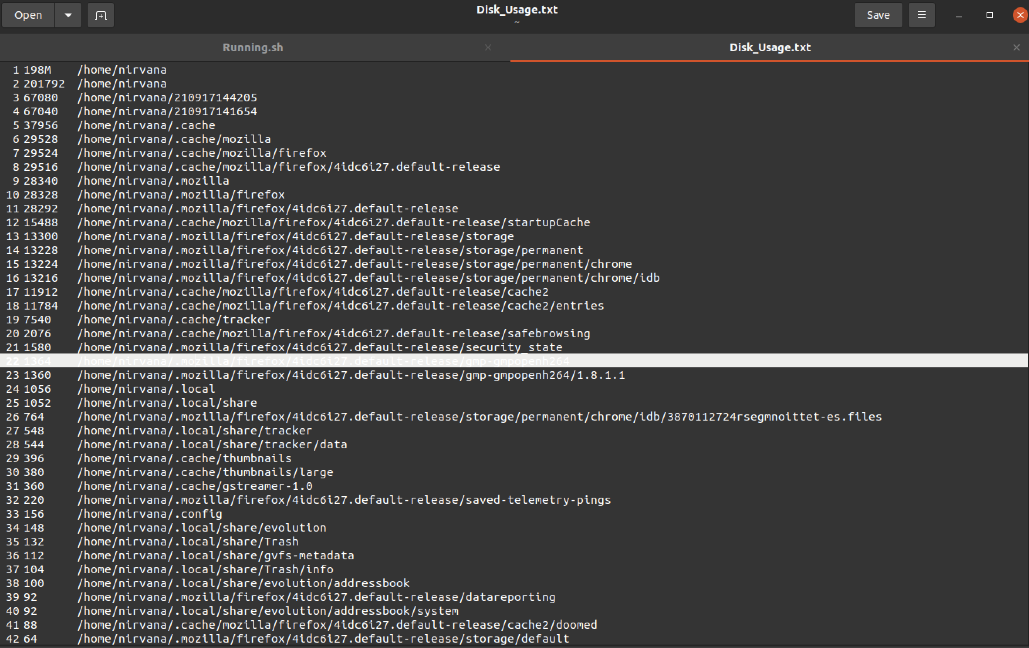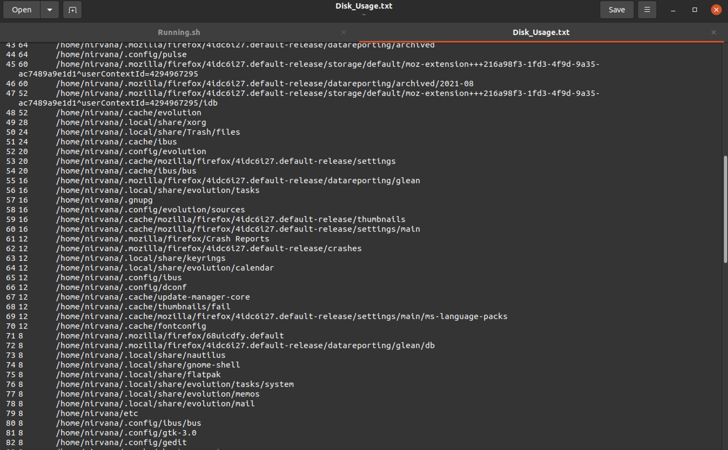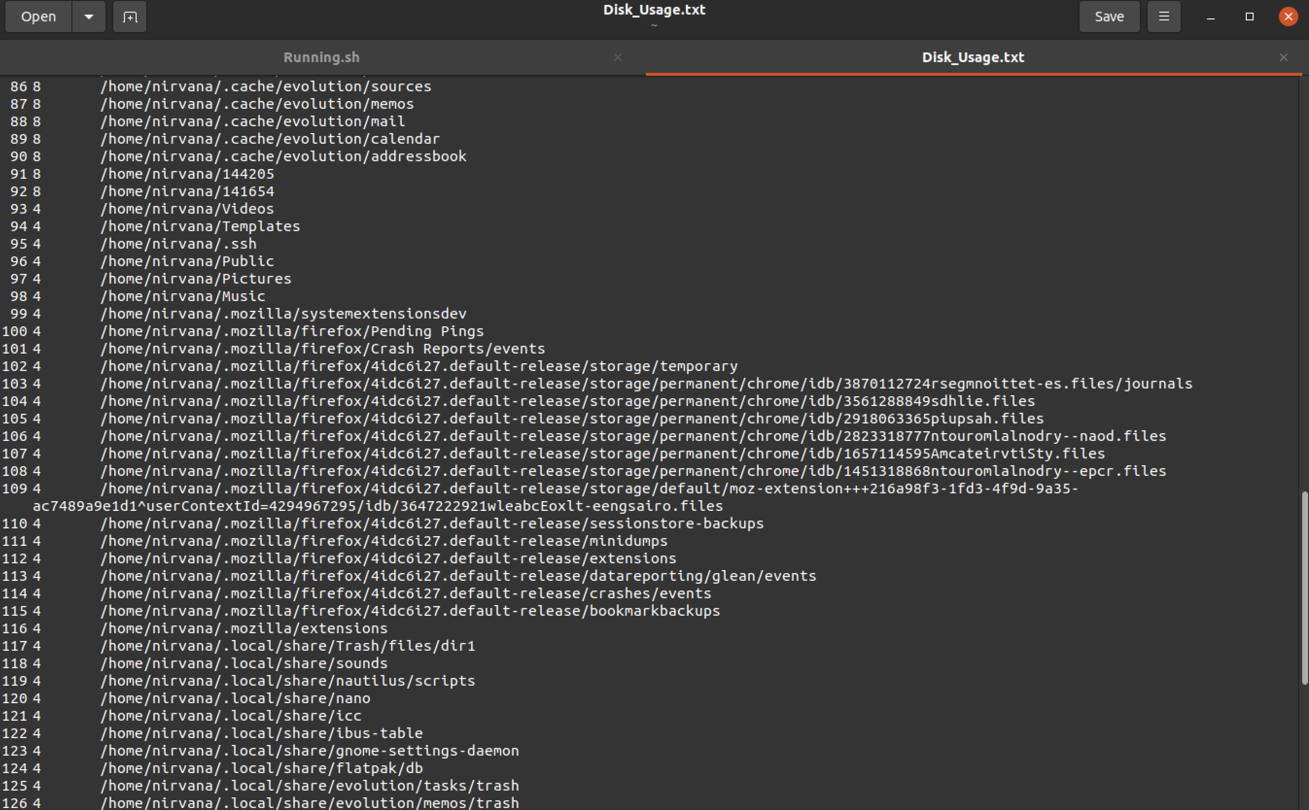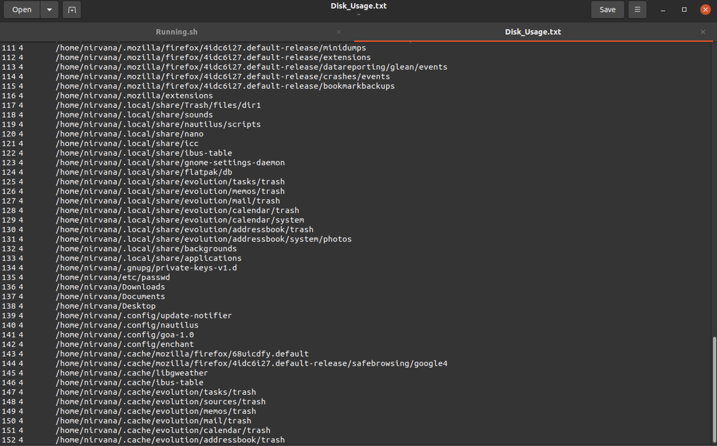

### Cpu_info.txt

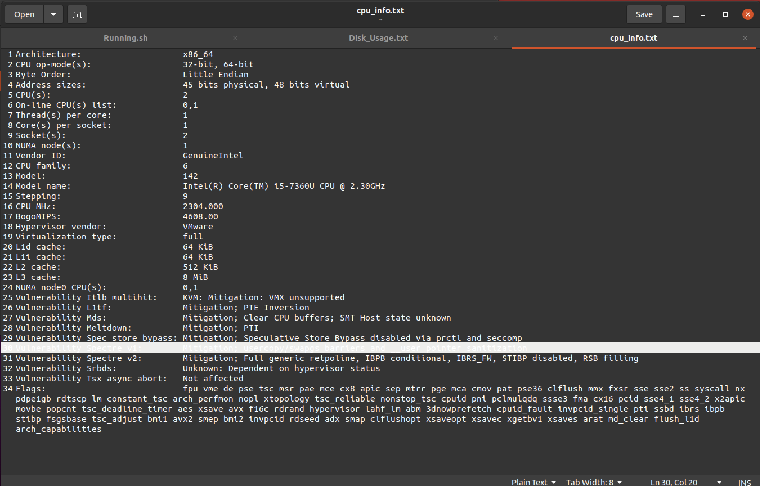

### Message_Count.txt

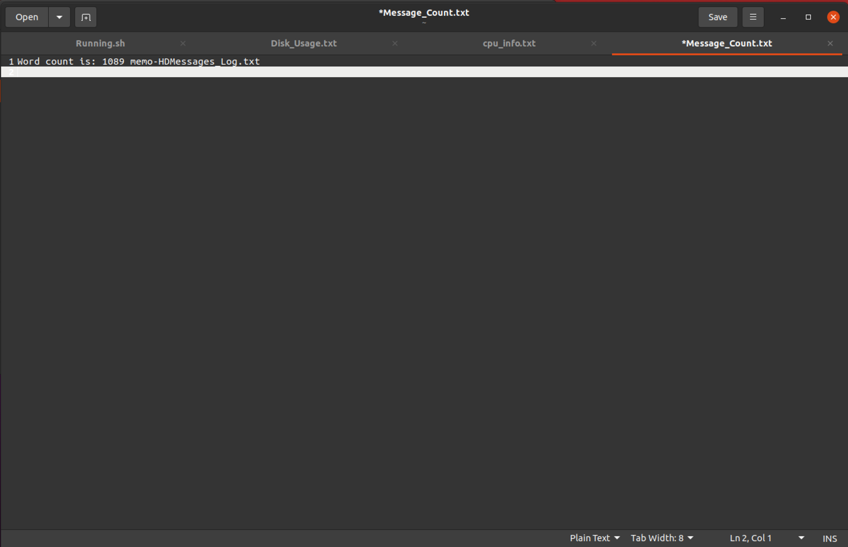

HDMessages_Log.txt 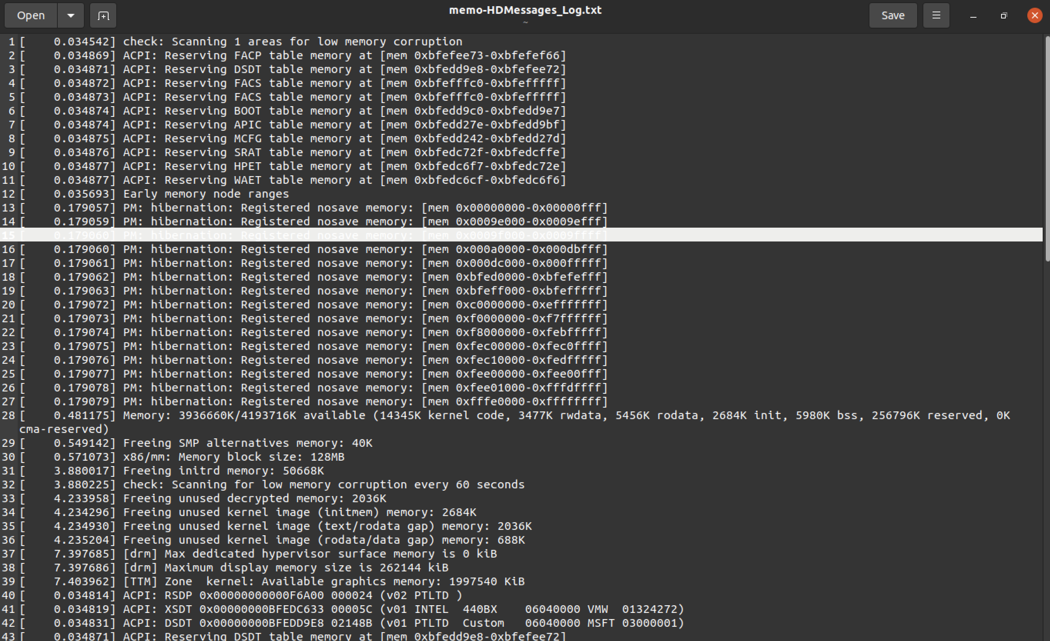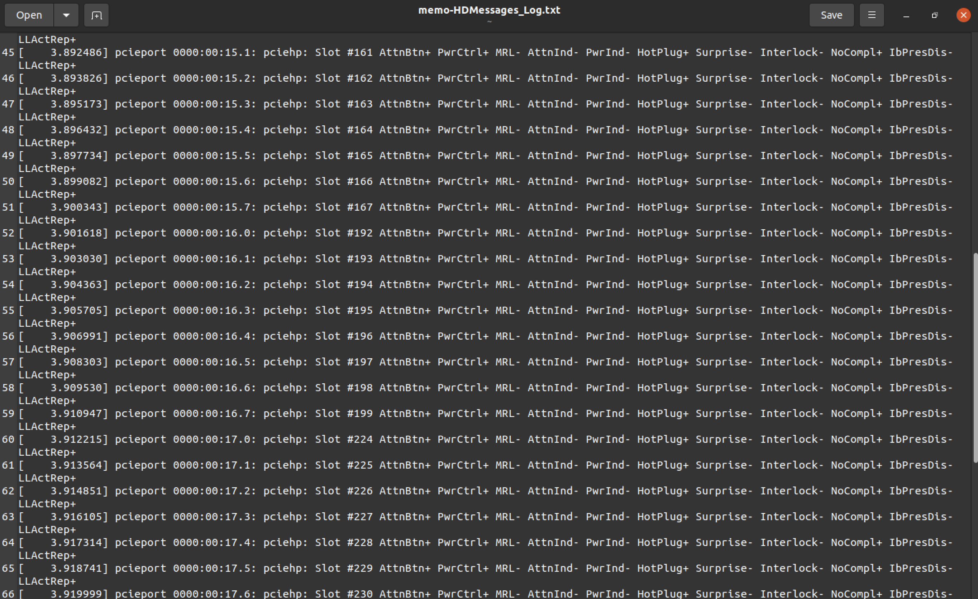

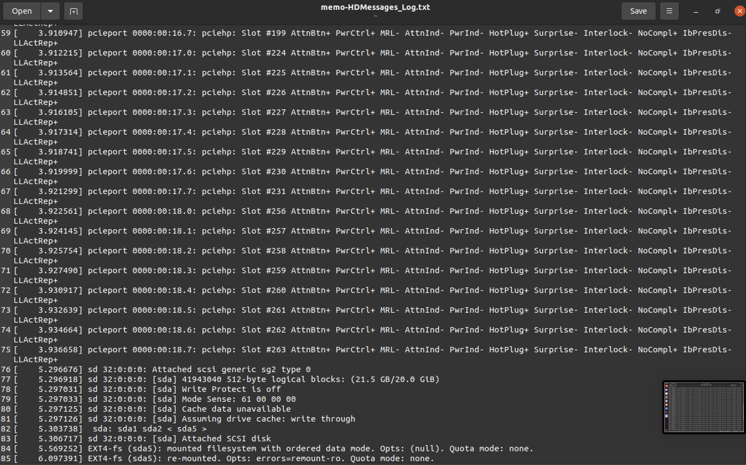

# Third Shell Script (FileSystem.sh)

#!/bin/bash

cat /dev/null > OUTFILE.txt #initialization

cat /dev/null > HOLDFILE.txt #erase current file content and add to empty file

## #sub1

function sub1(){

echo -e "\nDate/Time of Search: $(date +"%b %d %Y at %H:%M:%S")\n" >> OUTFILE.txt #Insert date and time

}

## #sub2

function sub2(){

#Takes from the user the username

echo "Enter username:"

read username

find /home/$username -size +8M |sort -nk7>> HOLDFILE.txt #Searching for files greater than 8MB in your home directory

echo -e "\n-----------FileSystem.sh----------"

echo -e "\nSearching for Files Larger Tan 8Mb starting in /home/HomeDir

Please Standby for the Search Results…" #Message

if [ -s HOLDFILE.txt ] #If the file is not empty

then

echo -e "\nNumber of files found: $(cat HOLDFILE.txt | wc -l)" #number of lines found in the HOLDFILE.txt

cat HOLDFILE.txt >> OUTFILE.txt #redirect them to OUTFILE.txt

else

echo -e "\nNo files were found that are larger than 8MB # If the file is empty, display the message

Exiting…"

fi #close if statment

}

## #sub3

function sub3(){

cat OUTFILE.txt #reads OUTFILE.txt and displays it on screen

echo -e "\nThese search results are stored in /home/HomeDir/OUTFILE.txt

Search complete…Exiting…\n" #required message

}

#calling sub functions

sub1

sub2

sub3

## Output

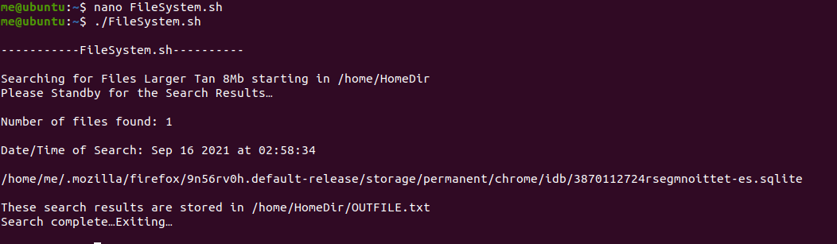

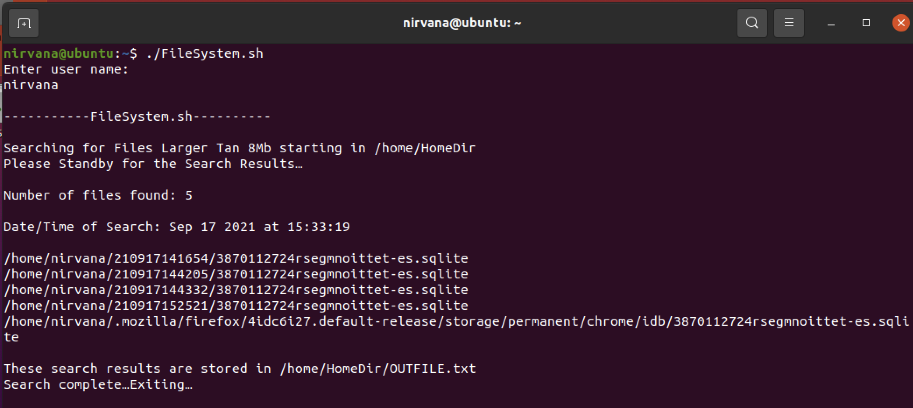

### HOLDFile.txt

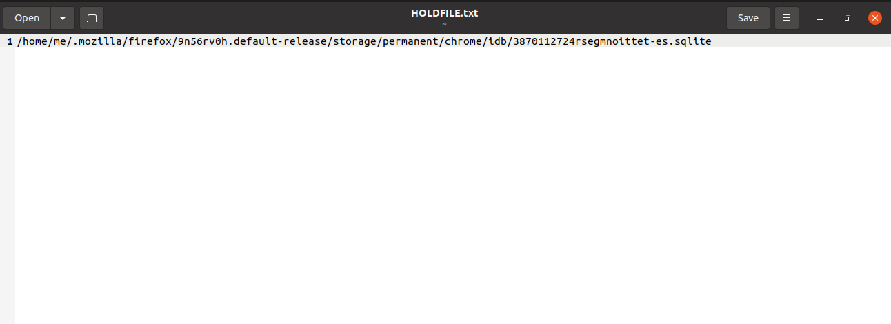

### OUTFILE.txt

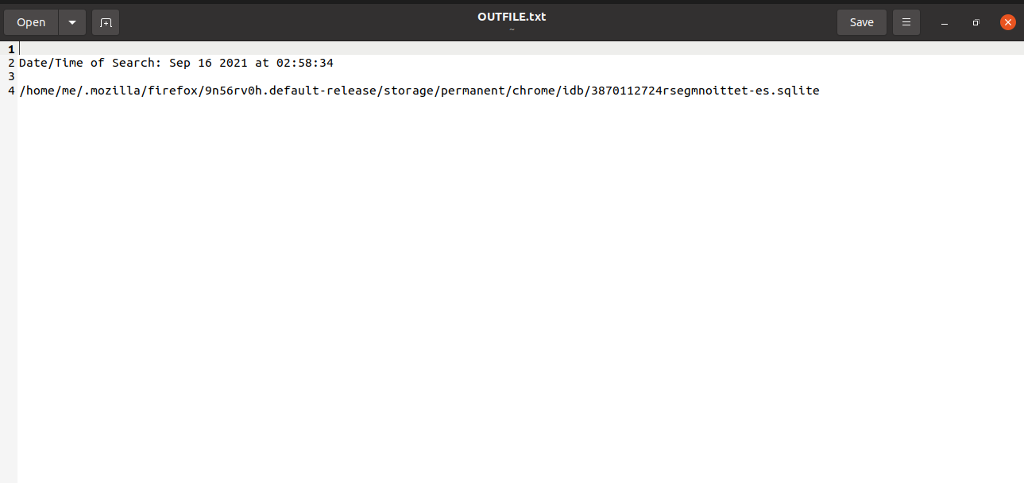

# Fourth Shell Script (ControlTraffic.sh)

#first subroutine

## Subroutine_1() {

apt-get upgrade & apt-get update #to update and upgrade

}

#second subroutine

## Subroutine_2(){

echo "\n\nThe status of the firewall"

ufw status #Check default status of the firewall

ufw default deny incoming # Deny incoming traffic

ufw allow OpenSSH #Allow incoming SSH connection through port 22

echo "\nEnabling the firewall"

ufw enable #Enable and start the firewall

echo "\n\n"

ufw status verbose #Checked status after the changes

}

Subroutine_1

Subroutine_2

## output

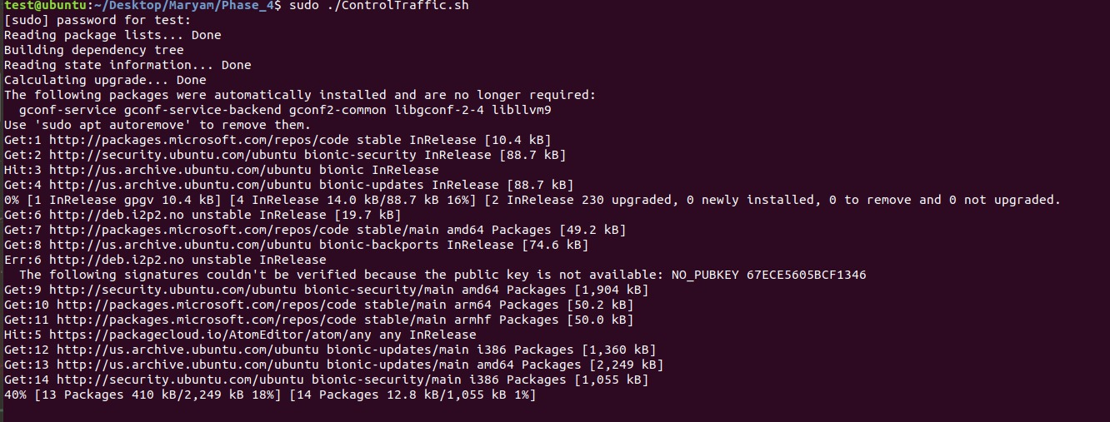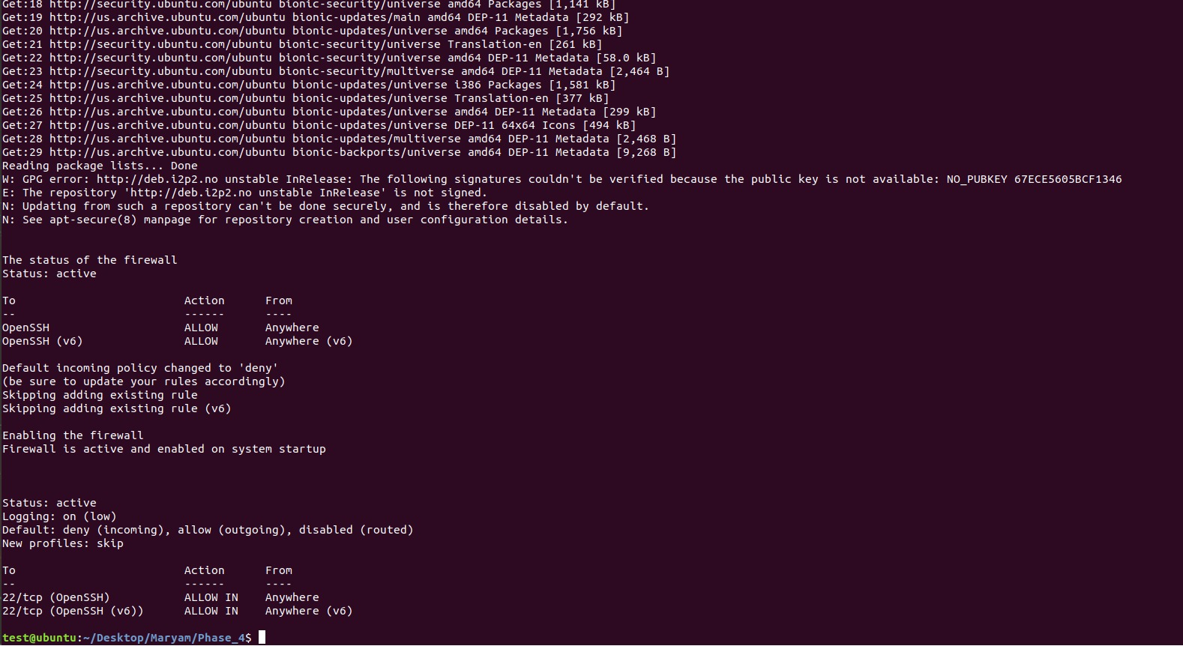

# Fifth Shell Script (Connectivity.sh)

#!/bin/bash

## #subroutine

sub(){

if ping -q -w1 -c1 google.com &>/dev/null #check if the system is online

then echo online #display online

#Ping the gateway with 10 packets each packet is 1KB and save it in /tmp/PINGRESULTS.TXT

ping -c10 -s1024 $(ip route show default | grep default |awk {'print $3'})>/tmp/PINGRESULTS.TXT

nslookup qu.edu.qa >>/tmp/PINGRESULTS.TXT #Query the Domain Name System to qu.edu.qa.

else echo offline #if we can not ping google, It is offline

ping -c 1 0 > /var/tmp/NETINFO.TXT #Ping local machine

echo "nameserver 8.8.8.8" | sudo tee /etc/resolv.conf 2> /dev/null >> /var/tmp/NETINFO.TXT

sudo apt-get install net-tools >> /var/tmp/NETINFO.TXT

ifconfig -a >> /var/tmp/NETINFO.TXT #display IP configuration

route -n >> /var/tmp/NETINFO.TXT #display Routing Table and save all work in /tmp/NETINFO.TXT

sleep 15; reboot #reboot the system after 15 seconds.

fi

}

#calling sub functions

sub

## output

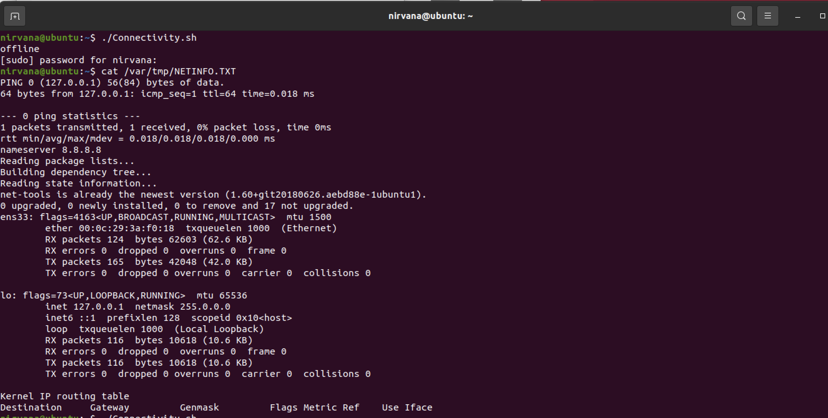

# Sixth Shell Script (Trap.sh)

#!/bin/bash

#subroutine to ignore signals

function Trap_Sign(){

trap '' INT TERM #Perform the following function incase of interruption from user for SIGINT & SIGTERM [CTRL+C];

while true; do

sleep 1

done

}

#function call

Trap_Sign

## output

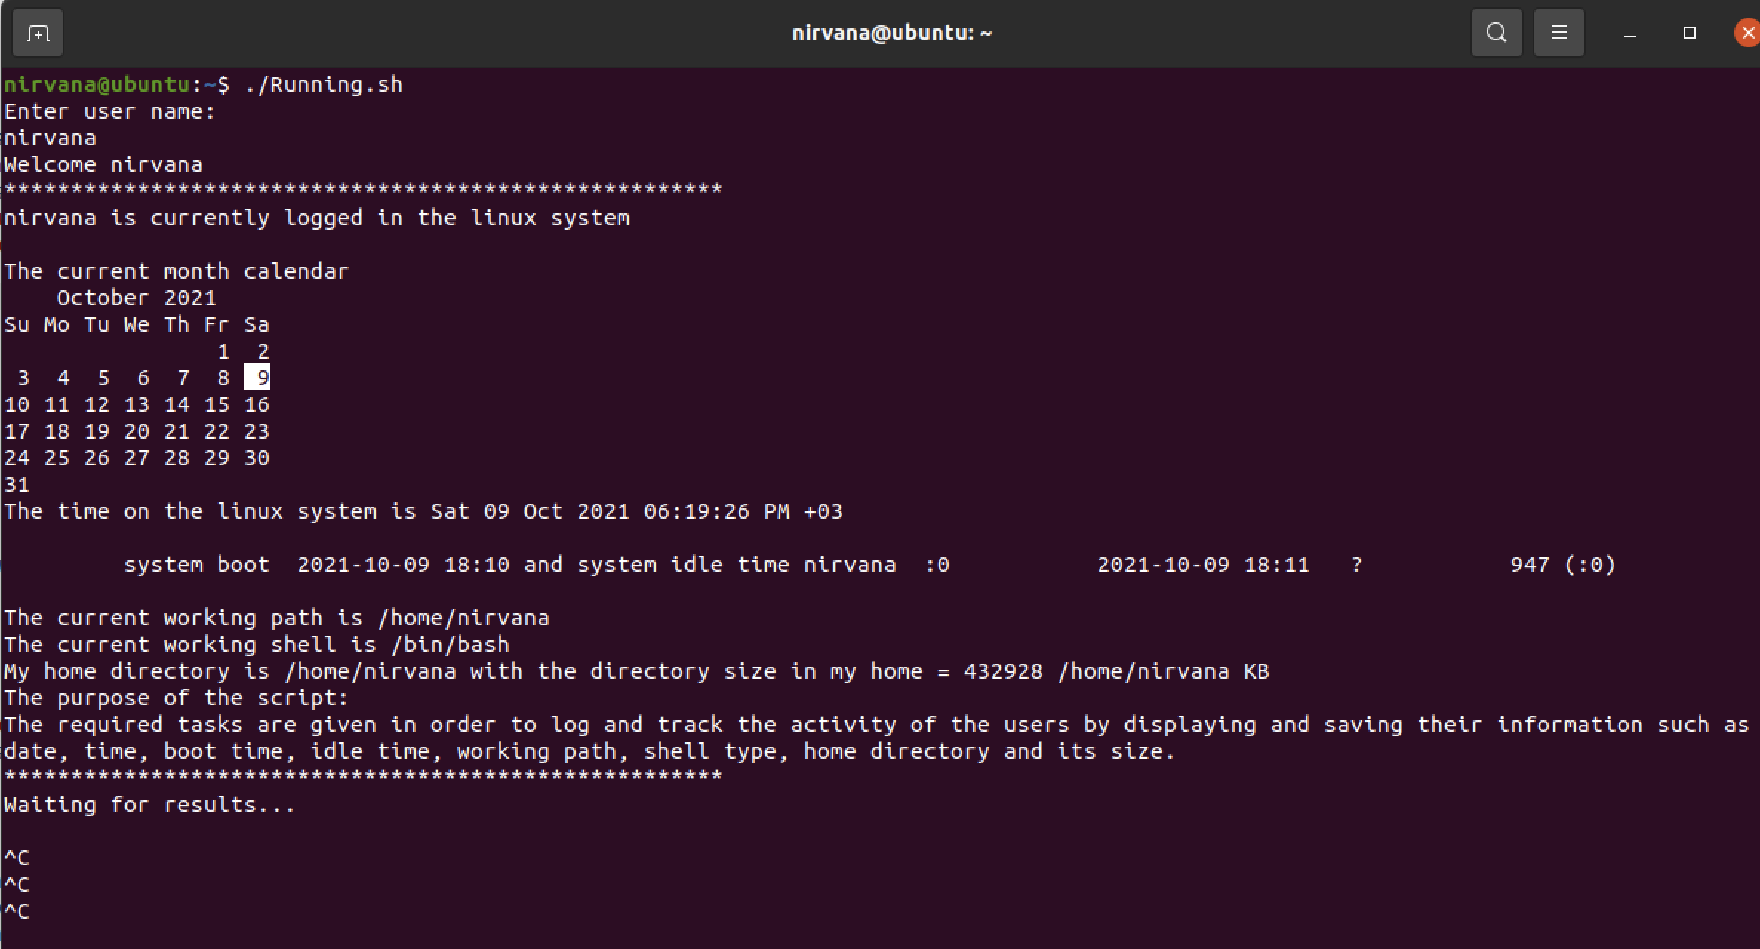

note: CTRL+C is trapped and doesnt terminate the process

# Part 2 – C programming

## Fibonnaccinumber.c

#include <stdio.h>

#include <time.h> //library for clock()

#include <stdlib.h> //library for atoi()

// This program designed to compute the Fibonacci number of the passed argument.

int fibnum(int n)

{

if (n<=1)

return n;

return fibnum(n-1) + fibnum(n-2);

}

int main(int argc, char *argv[]) //argc is the number of arguments, and argv is an array of strings containing the arguments.

{

clock_t time_start,time_end;

time_start = clock(); //assignment of time when the function start

char *num = argv[1]; //pass the number to first aegc

int n =atoi(num); //function to convert string to integer

printf("The Fibonacci number of %d is: %d ",n,fibnum(n));

time_end = clock(); //assignment of time when the function finish execution

double timetaken = ((double)(time_end - time_start))/CLOCKS_PER_SEC; //Calculate the elapsed time in seconds

printf("\nThe function took %f seconds to execute\n", timetaken);

return 0;

}

## Makefile

compile:

gcc Fibonaccinumber.c -o Fibonaccinumber

run:

./Fibonaccinumber 9

clean:

rm Fibonaccinumber

## output

